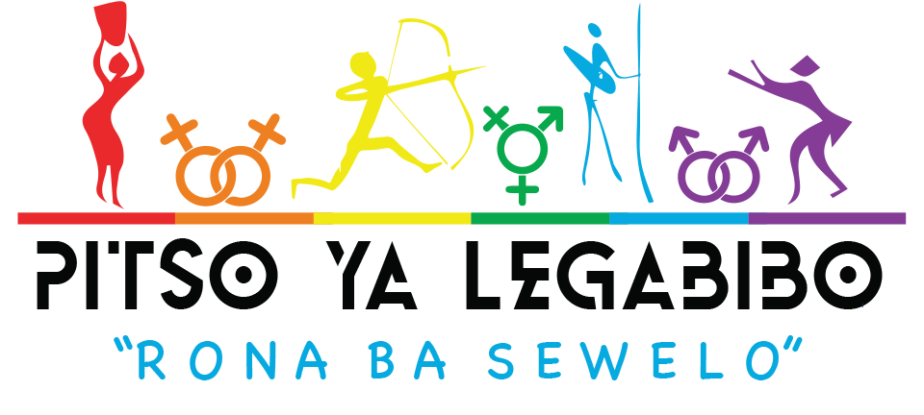 CONFERENCE APPLICATION FORM

|  |  |
| --- | --- |

**This form should be completed in English, please refer to the criteria document**

SECTION A

| PERSONAL DETAILS | | | | | | | | | | | | |
| --- | --- | --- | --- | --- | --- | --- | --- | --- | --- | --- | --- | --- |
| First name |  | | | | Last name / Surname | |  | | | | | |
| Telephone country code |  | Telephone number | | |  | | Fax number | | |  | | |
| Mobile number |  | | | | Email address |  | | | | | | |
| Physical address |  | | | | | | | | | | | |
| Postal address |  | | | | | | | | | City or town |  | |
| In which one of the following Districts are you applying from? Mark (X) only one option. | | | | | | | | | | | | |
| Kgalagadi | | |  | North East | | | |  | North West | | |  |
| Southern | | |  | Kweneng | | | |  |  | | |  |
| Central | | |  | Kgatleng | | | |  |  | | |  |
| Ghanzi | | |  | Chobe | | | |  |  | | |  |
|  | | |  | Other (specify) | | | |  | | | | |

| Which organization will you represent at the *Conference if any*? | | |  | | | | | | |
| --- | --- | --- | --- | --- | --- | --- | --- | --- | --- |
| What type of organization is it? Mark (X) only one option. | | | | | | | | | |
| Non-Governmental Organization |  | Private Company / Consultancy | | |  | Legal / Paralegal Advice Office | |  | |
| University Centre / Research Organization |  | Arts / Culture Group | | |  | Community-based Organization | |  | |
| Government or Intergovernmental Agency |  | Media / Publishing House | | |  | Faith-Based Institution | |  | |
| School |  | Funding Agency | | |  | Social Movement / Advocacy Group | |  | |
| Trade Union |  | Youth Group | | |  | Psycho-social Support Group | |  | |
| Health service delivery organization |  | Other (specify) | | |  | | | | |
| Which major area does the work of the organization focus on? Mark (X) only one option. | | | | | | | | | |
| General advocacy on LGBTI rights |  | General human rights, social and economic justice advocacy | | |  | HIV / AIDS or health | |  | |
| Human Rights advocacy but focused specifically on lesbians or gay men or trangender people, etc |  | Gender or gender-based violence | | |  | Visibility of LGBTI people | |  | |
| Institutional transformation |  | Religious ministry and outreach | | |  | Women’s rights / Feminism | |  | |
| Public policy development |  | Psychosocial support and wellbeing | | |  | News and related media production | |  | |
| Labour relations / workplace issues |  | Law reform | | |  | Social networking | |  | |
| Funding |  | Other (specify) | | |  | | | | |
| What is your association with / role in / position in this organization? | | | |  | | | | | |
| In which organization / company do you work, if any? | | | |  | | | | | |
| Which languages do you speak? | | | |  | | | | | |
| If your application is successful, will you definitely be available to participate in the Conference? YES or NO? | | | | | | |  | | |

| BIOGRAPHICAL NOTES: Please provide brief biographical notes that describe who you are in no more than 200 words. |
| --- |
|  |

SECTION B

| NEED | | |
| --- | --- | --- |
| Please explain why it is important for you to attend the “Rona ba Sewelo” conference, in no more than 500 words. |  | |
|  |  | |

SECTION C

| MOTIVATION |
| --- |

| What are you and/or your organization doing in promoting social justice, equality, and human rights for LGBTQIA+ persons in Botswana. Please explain briefly in no more than 500 words. |
| --- |
|  |

| What do you think is most needed to strengthen organizing, movement building, research, and advocacy to advance freedom, equality, and social inclusion of lesbian, gay, bisexual, transgender, and intersex people in Botswana? Please explain very briefly in no more than 500 words. |
| --- |
|  |

| How will you take your experience from ‘Rona Ba Sewelo’ back to your organization and/or community and what difference will it make? Please explain in no more than 500 words. |
| --- |
|  |

SECTION D

| DEMOGRAPHIC DATA: This section will enable us to map where and whom we are getting applications from so as to ensure appropriate reach and diversity of participation. Responses to these questions will not prejudice your application. |
| --- |

| In terms of sexual orientation, how do you identify yourself? Mark (X) only one option. | | | | | |
| --- | --- | --- | --- | --- | --- |
| Straight / Heterosexual |  | Bisexual |  | Gay man |  |
| Lesbian |  | Asexual |  | Don’t know / Other (specify) |  |

| In terms of gender, how do you identify yourself? Mark (X) only one option. | | | | | |
| --- | --- | --- | --- | --- | --- |
| Man |  | Woman |  | Gender non-conforming |  |
| Don’t know / Other (specify) |  |  |  |  |  |

| In terms of the relation between sex and gender, how do you identify yourself? Mark (X) only one option. | | | | | |
| --- | --- | --- | --- | --- | --- |
| Cisgender |  | Transgender |  | Not applicable / Don’t know / Other |  |

*Cisgender* means that your gender expression matches the sex that you were born with. For example, you were born female and your gender identity is that of a woman, or you were born male and your gender identity is that of a man. *Transgender* means that you do not gender identify with the sex you were born with.

| In terms of your biological sex, how do you identify? Mark (X) only one option. | | | |
| --- | --- | --- | --- |
| Intersex |  | Female |  |
| Male |  | Other |  |

| What is your age? Mark (X) only one option. | | | | | |
| --- | --- | --- | --- | --- | --- |
| Under 25 years old |  | Between 25 years and 45 years old |  | Over 45 years old |  |

| What is your employment status? Mark (X) only one option. | | | | | |
| --- | --- | --- | --- | --- | --- |
| Unemployed and looking for work |  | Self employed |  | Employed part-time |  |
| Employed full time |  | Full time student (not working) |  | Other (specify) |  |

| What are your living arrangements? Mark (X) only one option. | | | | | |
| --- | --- | --- | --- | --- | --- |
| I live in a property that I own |  | I live in a property that I rent |  | I rent a room in a shared house |  |
| I live with my parents |  | I live in an informal settlement |  | I do not have formal housing |  |
| I live in a hosel or student accommodation |  | Other (specify) |  |  |  |

| Do you identify with a particular religious tradition? Mark (X) only one option. | | | | | |
| --- | --- | --- | --- | --- | --- |
| Buddhist |  | African Traditional Religion |  | Anglican Christian |  |
| Roman Catholic Christian |  | Evangelical Christian |  | African Indigenous Church Christian |  |
| Lutheran Christian |  | Methodist Christian |  | Pentecostal Christian |  |
| Muslim |  | Hindu |  | Jewish |  |
| Orthodox Christian |  | No religion |  | Other (specify) |  |

| Do you have any special needs in terms of disability? | Yes |  | No |  | Please specify: |
| --- | --- | --- | --- | --- | --- |

SECTION E

SECTION F

| DECLARATION | | | | |
| --- | --- | --- | --- | --- |
| I confirm that all the information given in this application is correct. I confirm that I am submitting this application and I am aware that my name, image, and possibly the name of the organization that I represent may be shared publicly in the regular accountability reporting and public communications of LEGABIBO. | | | | |
| Full name in lieu of signature |  | | | |
| Date |  | Place |  | |
| NOTE: When completed, this entire form should be no longer than 4 and a half pages. Applications that are longer may not be considered. | | | | |

Please make sure that you submit your application by the closing date that is given. Late applications will not be accepted. You must submit your application by email to[**legabibo@legabibo.org.bw**](mailto:legabibo@legabibo.org.bw)with the subject line:*Application for Rona Ba Sewelo,* Do not send any appendices or attachments other than this application form. Applications submitted by fax or post or in any other way will not be accepted.